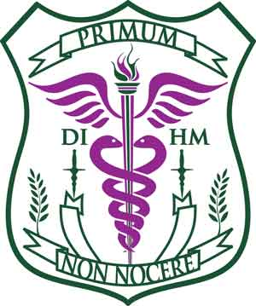

**DA VINCI INSTITUTE OF HOLISTIC MEDICINE**

**CLINICAL PRACTICUM LOG**

All our students need to log a few hundred clinical hours at various Natural Healthcare Centers around the world. Our student has chosen yourselves and your Center in order to gain some clinical practice based on your clinical expertise.

We would appreciate if you, the healthcare professional, complete and sign this Clinical Practicum Log so that the student can include this in their transcript. Thank you for playing such an important role in this student’s education!

**DEMOGRAPHIC DETAILS**

Name of student:

Student’s email:

Student’s phone number:

Degree being taken:

**DETAILS OF TRAINING CENTER**

Name of Center:

Address:

Name of Supervising Healthcare Practitioner:  
  
Qualifications of practitioner:

Email contact of practitioner:

**STUDENT’S LEARNING TASKS**

Please include what the student has learned below, including the number of hours spent on each task – you may continue on another page if necessary:

**TASKS NO OF HOURS**

1.

2.

3.

4.

5.

6.

7.

8.

9.

10.

**TOTAL HOURS:**

**LEARNING FEEDBACK**

Please provide any constructive feedback you would like to give this student so that they may benefit in the future for fine-tuning and improving their services:

Signed: _______________________________________________

Healthcare Practitioner (Full name): _________________________

Date: _____________

We again thank you most kindly for your efforts to help this student gain clinical hours as part of their training for their degree in Naturopathy and Holistic Medicine.

Prof. George Georgiou, Ph.D.,N.D.,D.Sc (AM).,M.Sc.,B.Sc  
Director/Founder, Da Vinci Institute of Holistic Medicine  
[www.collegenaturalmedicine.com](http://www.collegenaturalmedicine.com)   
[admin@collegenaturalmedicine.com](mailto:admin@collegenaturalmedicine.com)